**Welcome Families to the 2023-2024 School Year!**

Teacher Background:

I have been working with students for the last 10 years. This is my 3rd year working for the Yonkers Public Schools.

Communication:

This year our classroom theme will be Bees. Students will focus on **Beeing** kind, **Beeing** good listeners, and always **Beeing** ready to learn.

 I am looking forward to working with your children on all their goals this year. Please expect update from me that will list the monthly tasks.

If there is anything that you would like me to focus on with your child, please let me know.

Looking forward to Buzzing with you this year!

Amber Greene

Email: [Agreene@yonkerspublicschools.org](mailto:Agreene@yonkerspublicschools.org)

Ms. B **Classroom Staff**

Few of my Favorite Things:

Colors: Blue and Red

Foods: Pizza and Salad

Drinks: Starbucks

Favorite children's book:

“Pete The Cat”

Hobbies: Reading, Watching Movies, and Shopping on Amazon and at Target!

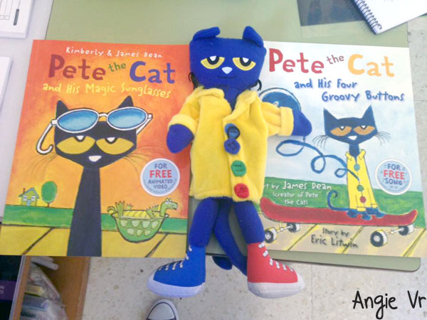

My name is Amber Greene, and I amso happy to be working with your children for the 2023-2024 school year here at Cesar Chavez!